**COMSATS University Islamabad (CUI)**

**Project Report**

**for**

**DATABASE-DRIVEN ANALYSIS OF THE IMPACT OF**

**REMOTE WORK ON MENTAL HEALTH**

(Version 1.1)

***By***

**Taha Bin Tazeem CIIT/SP23-BDS-051/ISB**

**Haidar Ali Thaheem CIIT/SP23-BDS-015/ISB**

***Supervisor*Mr. Muhammad Harris**

***Bachelor of Science in Computer Science (2023-2027)***

**Table of Contents**

Abstract 1

Introduction 2

Problem Statement 2

Problem Solution/Objectives of the Proposed System 2

Objectives 2

Related System Analysis/Literature Review 3

Vision Statement 3

Scope 3

Modules 4

Module 1: Data Import 4

Module 2: Schema and ERD Designing 4

Module 3: Query Execution 4

Module 4: Result Analysis 4

Entities and their Attributes 5

Entities and their Relations 6

Entity Relation Diagram 6

Screenshots 7

Database Setup 7

Query Execution 8

Query Outputs 9

Visualizations 10

GitHub Repository 11

System Limitations/Constraints 12

Data Gathering Approach 12

Tools and Technologies 13

Module-Based Work Division 13

References 13

**Project Category: (**Select all the major domains of proposed project**)**

□ **A-**Desktop Application/Information System □ **B-**Web Application/Web Application based Information System □ **C-**Problem Solving and Artificial Intelligence □ **D-**Simulation and Modeling □ **E-**Smartphone Application

□ **F-**Smartphone Game □ **G-**Networks □ **H-**Image Processing□ Other (specify category) ________________

# Check mark Emoji Cut, copy, and paste Computer Icons Copying, Emoji, blue, computer Network, angle png | PNGWing

* Database Management Systems
* Data Analysis and Visualization
* Mental Health and Well-being
* Remote Work and Productivity

# Abstract

Remote work's growing prominence has sparked concerns about its effects on mental health. Existing studies explore this relationship but lack detailed analysis with modern database tools. This project bridges that gap by leveraging MongoDB to analyse employee data, uncovering how remote work influences mental health, stress, and work-life balance. By identifying trends, this project aims to inform organizations on improving employee well-being. Its significance lies in its ability to provide actionable insights, benefiting companies in adapting to remote and hybrid work models effectively.

# Introduction

The project aims to explore the relationship between remote work and mental health, motivated by the rise in remote work practices and mental health challenges. By analysing a dataset sourced from Kaggle, the project uses MongoDB to store and query data efficiently. The system processes data related to employee demographics, work conditions, and mental health factors to derive insights. The proposed database system will allow organizations to make data-driven decisions to enhance employee well-being.

# Problem Statement

The shift towards remote work has created challenges for organizations in understanding its impact on employees' mental health. Current systems are limited in providing holistic insights from large datasets, often leaving companies without adequate data to address employee stress and improve work-life balance. This project solves this problem by using advanced database queries to analyse the relationship between remote work and mental health.

# Problem Solution/Objectives of the Proposed System

The project utilizes MongoDB to query and analyse data on remote work and mental health. Objectives include:

1. Analyse remote work's impact on mental health, stress, and work-life balance.
2. Enable aggregation queries to identify trends and correlations in the data.
3. Store query results for visualization and extended analysis.

Objectives:

BO-1: Analyse the relationship between remote work and mental health challenges.

BO-2: Provide actionable data insights for organizations.

BO-3: Develop a scalable MongoDB-based system for employee data analysis.

# Related System Analysis/Literature Review

| **Application Name** | **Weakness** | **Proposed Project Solution** |
| --- | --- | --- |
| **Survey Systems** | Lack of advanced data processing | Utilizes MongoDB for efficient aggregation queries. |
| **HR Tools** | Limited focus on mental health | Focused analysis of mental health and work conditions. |
| **BI Tools** | High cost, low customization | Open-source, customizable MongoDB-based solution. |

# Vision Statement

For organizations analysing the impact of remote work on employee well-being, the Remote Work and Mental Health Database Project is a MongoDB-based system that efficiently processes and analyses employee data. Unlike traditional survey tools, this project provides in-depth aggregation and trend analysis, offering actionable insights to improve work environments.

# Scope

The system processes data on demographics, work conditions, and mental health factors using MongoDB. Features include importing datasets, running aggregation queries, and exporting results. Future enhancements may include data visualization and a user-friendly frontend.

# Modules

## Module 1: Data Import

FE-1: Import CSV data into MongoDB.

FE-2: Verify data integrity.

## Module 2: Schema and ERD Designing

FE-1: Understanding the schema.

FE-2: Crafting the ERD.

## Module 3: Query Execution

FE-1: Execute pre-defined aggregation queries.

FE-2: Save results as JSON.

## Module 4: Result Analysis

FE-1: Analyse JSON outputs for trends.

FE-2: Prepare insights for visualization.

# Entities and their Attributes

1. **Employee**

* Employee_ID (Primary Key, varchar)
* Age (int)
* Gender (varchar)
* Job_Role (varchar)
* Industry (varchar)
* Years_of_Experience (int)
* Work_Location (varchar)
* Region (varchar)

1. **Work_Statistics**

* Record_ID (Primary Key, int, Auto-increment)
* Employee_ID (Foreign Key, varchar)
* Hours_Worked_Per_Week (int)
* Number_of_Virtual_Meetings (int)
* Work_Life_Balance_Rating (int, 1-5 scale)
* Company_Support_for_Remote_Work (int, 1-5 scale)

1. **Mental_Health**

* Record_ID (Primary Key, int, Auto-increment)
* Employee_ID (Foreign Key, varchar)
* Stress_Level (varchar, Low, Medium, High)
* Mental_Health_Condition (varchar)
* Access_to_Mental_Health_Resources (varchar, Yes/No)
* Productivity_Change (varchar, Increase, Decrease, No Change)
* Satisfaction_with_Remote_Work (varchar)
* Social_Isolation_Rating (int, 1-5 scale)

1. **Lifestyle**

* Record_ID (Primary Key, int, Auto-increment)
* Employee_ID (Foreign Key, varchar)
* Physical_Activity (varchar, Daily, Weekly, None)
* Sleep_Quality (varchar, Good, Average, Poor)

# Entities and their Relations

1. **Employee ↔ Work Statistics:** One-to-many relationship, an employee can have multiple work statistics records.
2. **Employee ↔ Mental Health:** One-to-many relationship, an employee can have multiple mental health records.
3. **Employee ↔ Lifestyle:** One-to-many relationship, an employee can have multiple lifestyle records.

# Entity Relation Diagram

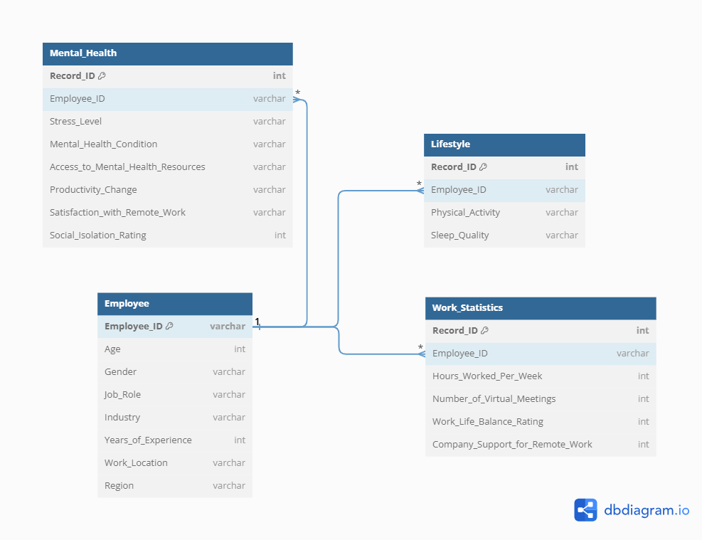

# Screenshots

## Database Setup

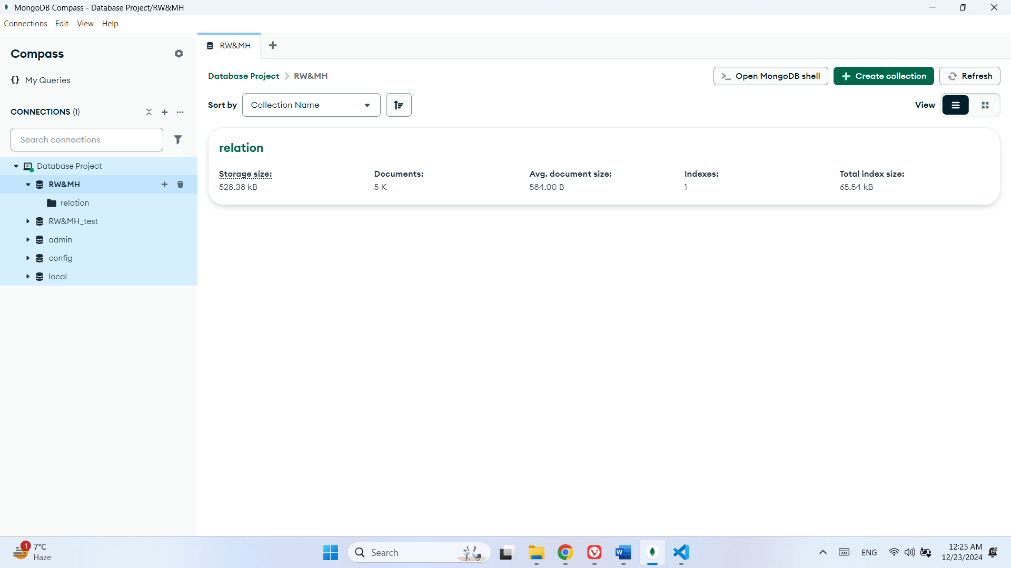

Description: Shows how the dataset appears in MongoDB Compass.

## Query Execution

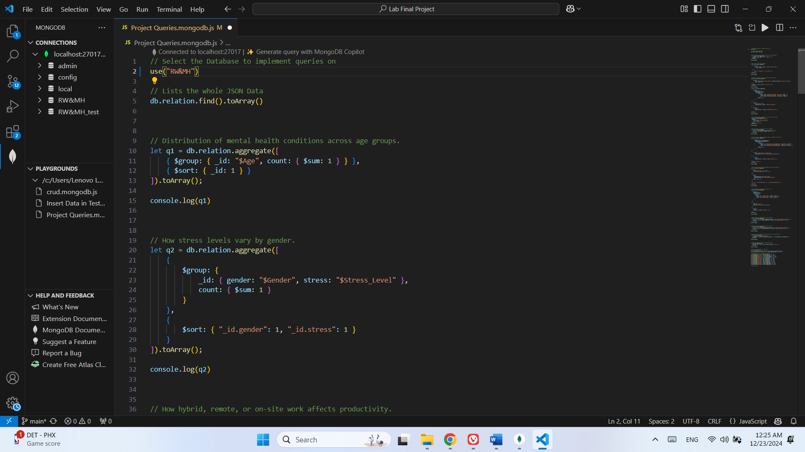

Description: VS Code with query files open

## Query Outputs

Description: JSON files created because of executing the queries.

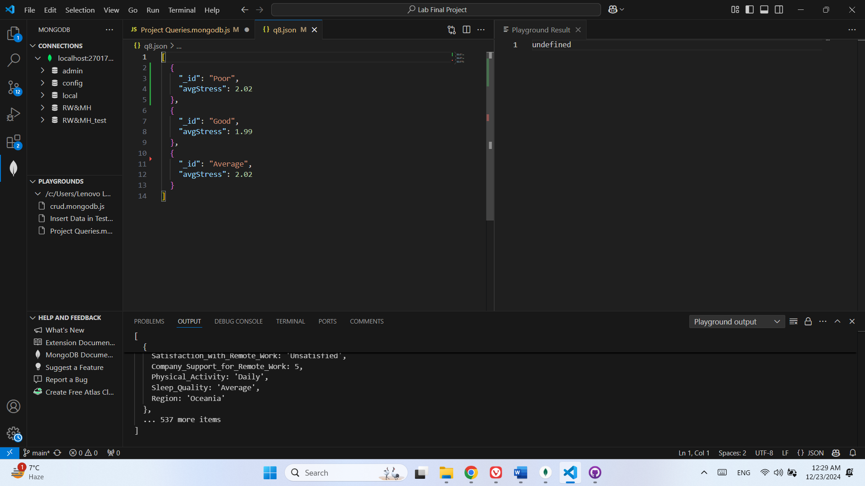

Description: A sample query result.

## Visualizations

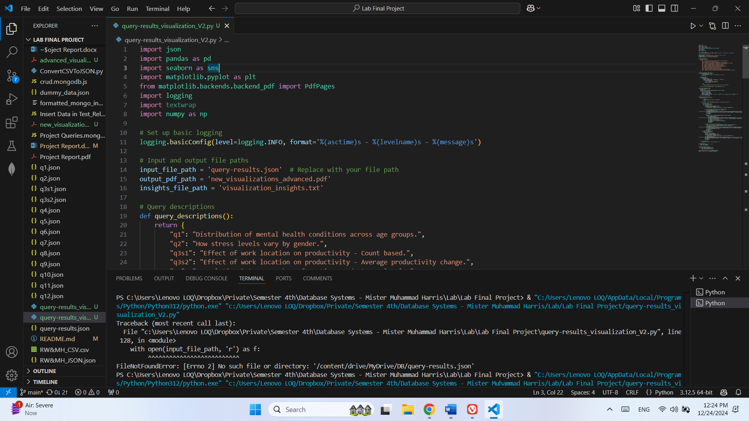

Description: The query results are the visualized for better insights understanding.

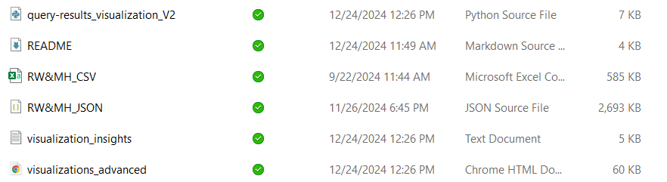

Description: The visualizations and their insights are saved in individual files.

## GitHub Repository

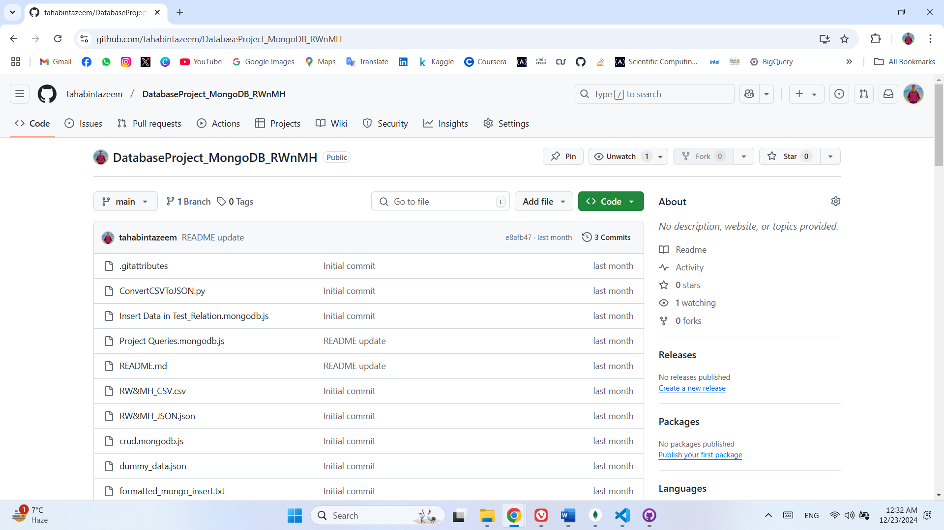 Description: [GitHub repository](https://github.com/tahabintazeem/DatabaseProject_MongoDB_RWnMH) structure with README, query files, and results folder.

Description: Open README on GitHub.

# System Limitations/Constraints

LI-1: Limited to MongoDB for database operations.

LI-2: Requires high computational resources for large datasets.

# Data Gathering Approach

The project utilizes secondary data sourced from Kaggle, processed using MongoDB. Additional insights could be gathered through organizational surveys or interviews for extended analysis.

# Tools and Technologies

| **Tools** | **Version** | **Rationale** |
| --- | --- | --- |
| MongoDB | 6.0 | Database storage and aggregation queries |
| Node.js | 16.0 | Script execution and integration |
| Python | 3.9 | Visualization |

# Module-Based Work Division

| **Student Name** | **Registration Number** | **Responsibility** |
| --- | --- | --- |
| Taha Bin Tazeem | SP23-BDS-051 | Module 1 and Module 3 |
| Haidar Ali Thaheem | SP23-BDS-015 | Module 2 and Module 4 |

# References

* Waqi786. “Remote Work and Mental Health Dataset.” Kaggle, 2022. [Online]. Available:

<https://www.kaggle.com/datasets/waqi786/remote-work-and-mental-health/data>

* GitHub Repo of the Project available at: <https://github.com/tahabintazeem/DatabaseProject_MongoDB_RWnMH/blob>